COMPUTER ORGANIZATION AND ASSEMBLY LANGUAGE

TOPIC:
INCREMENT AND DECREMENT

NAME:
MUHAMMAD TALHA
SECTION:
4/A
ROLL#:
241890

INSTRUCTOR:
MS ROMANA MAROOF

ACTIVITY #1
INCREMENET AND ITS EFFECTS ON FLAGS
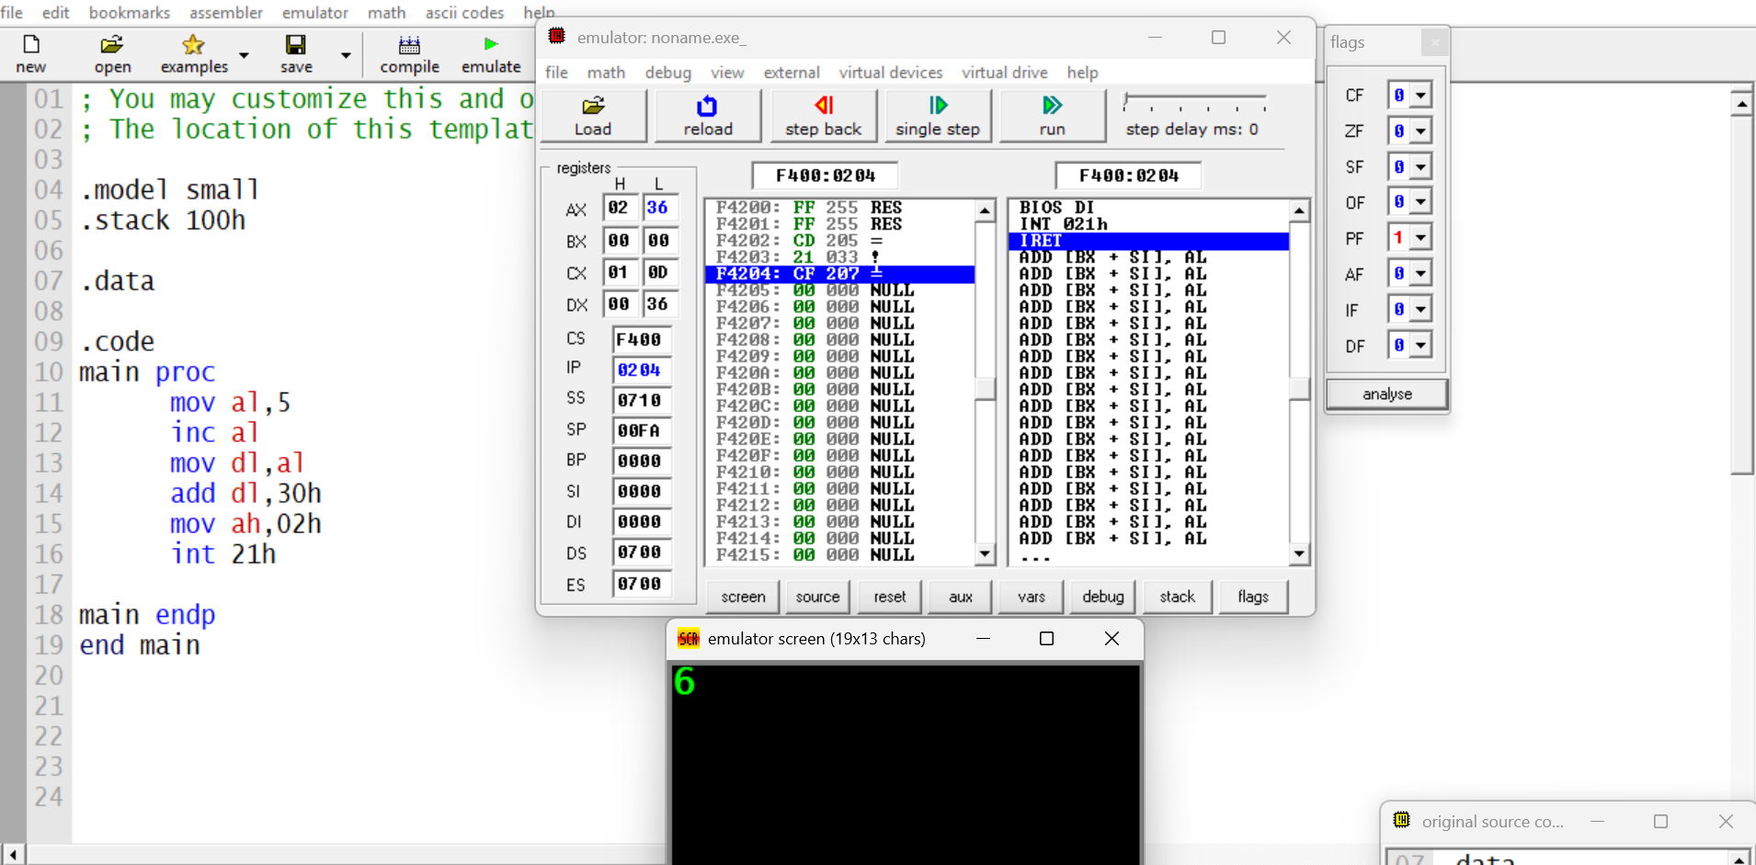
RESULTS:
STEPS:
1.al=5
2. Increment al, pf slag becomes 1 and al becomes 6
3. mov value of al to dl
4. add 30 to print the number rather than asci
5. mov ah 02 prints the value of dl

LAB ACTIVITY 5.2
DECREMENET AND ITS EFFECTS ON FLAGS
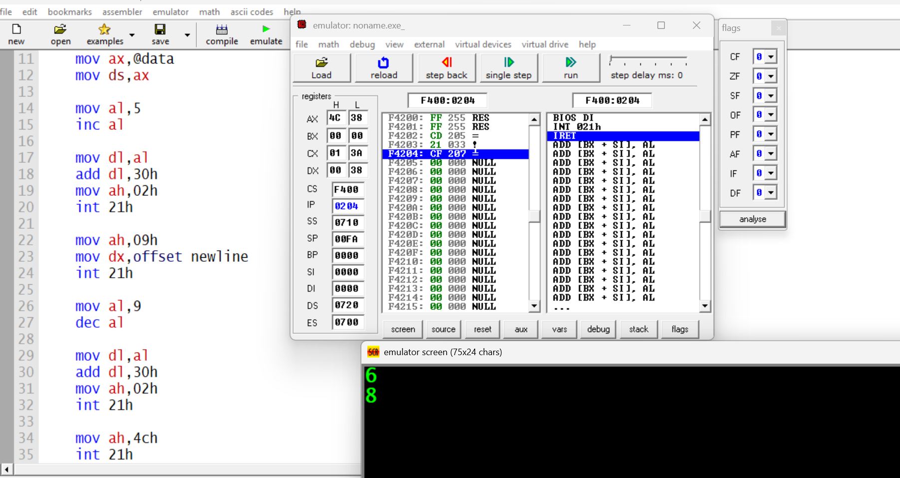
RESULTS:
STEPS:
- al becomes 9 (no flag changes)
- at DEC al: al becomes 8 (zf=0, sf=0, of=0, cf unchanged)
- dl gets 8 (no flag changes)
- converts 8 to ascii '8' (flags updated according to addition)
- selects print function (no flag changes)

LAB ACTIVITY 5.3
JUMPS
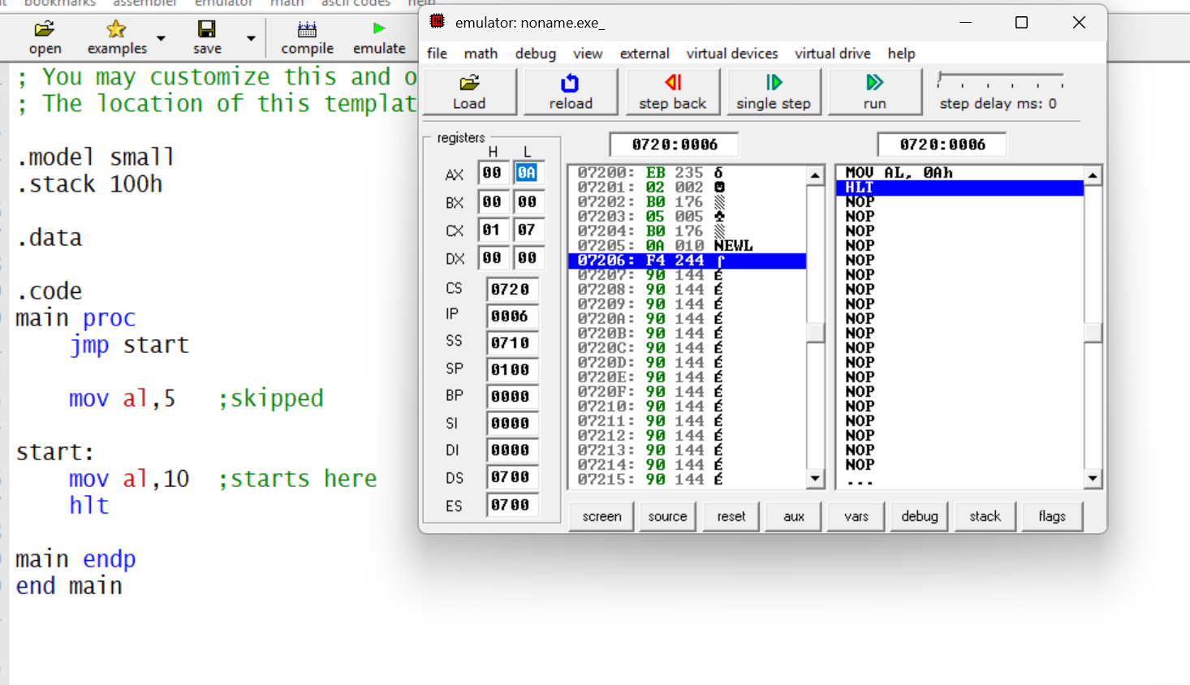
RESULTS:
STEPS:
- jmp start: processor jumps directly to the label start.
- mov al,5: skipped because of the jump.
- start: label where execution continues.
- mov al,10: loads the value 10 into the AL register.
- hlt: stops the processor.

